2015 PACIFIC REGION of NATIONAL GARDEN CLUBS CONVENTION
72nd Annual Convention – April 20-22, 2015
“From the Mountains, to the Valleys, To the Waters”

~Monday evening banquet~ “Jane Franklin Mecom, 18th Century Woman”
Kay Huston is a retired teacher who has taught approximately 30 years in Oregon. Her classroom experience includes teaching grades 2 – 8, middle school librarian, coordinator of Talented & Gifted programs for grades 4 – 8, and authorship of a series of language art books for grades 6 – 8.

In 1963 she received a B.S. from Los Angeles State College and an M.A. from the University of Portland in 1981. Kay has done extensive research and study in 18th century history, specifically the history and personalities of the American Revolution.

Currently, she teaches classes to senior citizens throughout Lane County and has taught Elderhostel groups through George University in Newberg, Oregon. She also offers living history presentations, done in first person and costume, of Abigail Adams, Martha Washington, Eliza Lucas Pinckney, and Jane Franklin Mecom.
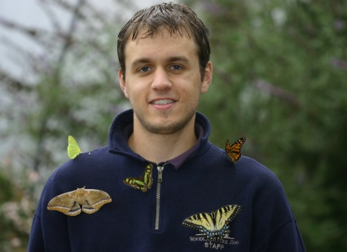
~Tuesday luncheon~ “Gardening for Butterflies in the Pacific Region”
David Droppers has been studying butterflies and moths for over 10 years. His primary interest is reaction to populations and community composition after management actions. He has put his skills to work for the National Park Service, Forest Service, Woodland Park Zoo, among many others. An all-around naturalist, he enjoys working with a variety of wildlife and plants.

David received his Bachelor's degree in Environmental Science and Resource Management from the University of Washington, and is currently completing his Master's degree at Western Washington University.

~Tuesday evening banquet~
“From the Mountains, From the Valleys, From the Waters”
Char Mutschler is an accredited NGC instructor of Floral Design, instructing Flower Show School classes, Symposiums, seminars and workshops throughout the U.S. She served 6 years on the NGC Flower Show School Committee as an Accrediting Chair and currently serves as NGC Symposium chair for 4 eastern regions.

Among her many accomplishments she is a speaker and presenter on innovative floral design with 30+ years of experience and travels throughout the U.S. giving floral design presentations at state conventions, judges councils’ special events, arrangers’ guilds and NGC meetings.

She is an American Rose Society (ARS) Accredited Horticulture and Arrangement Judge and served as the Pacific NW District Arrangement Chair for 10 years and is certified as a Consulting Rosarian.

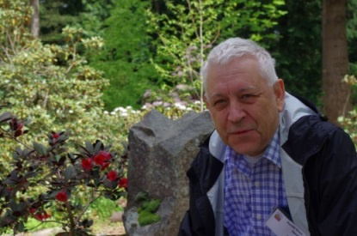
~Wednesday luncheon~ “If I Were a Rhododendron”
Harold Greer needs little introduction to members of the rhododendron world. He is undeniably one the leading authorities on the genus…and many consider him the best! Having worked with rhododendrons and azaleas for 50 years, Harold has a depth of knowledge that few can match.

He and his wife Nancy own Greer Gardens, a wonderful nursery located in Eugene, OR that specializes in “rhodies” and azaleas. Harold is renowned author, a celebrated hybridizer, a phenomenal photographer, and a very entertaining speaker.

2014 PACIFIC REGION of NATIONAL GARDEN CLUBS CONVENTION
72nd Annual Convention – April 20-22, 2015
“From the Mountains, to the Valleys, To the Waters”
~Wednesday evening after banquet~ Band Concert
New Horizons Band is a part of a nationwide band program that was initiated in New York State about 20 years ago for older adults who want to be part of a concert band. Every September, the group adds a “beginning” level group for people who always wanted to learn to play a band instrument but didn’t or who played an instrument many, many years ago and want to pursue playing again!

Our directors are Sherry Cossey and Tim Prendergast. Sherry taught band at Kennedy Middle School for 32 years, is retired, plays clarinet with the Eugene Symphonic Band, and is active in Eugene Garden Club. Tim, recently retired, is a guitarist, taught band and choir in Cottage Grove at Lincoln Middle School and also conducts the One More Time Marching Band in Eugene.

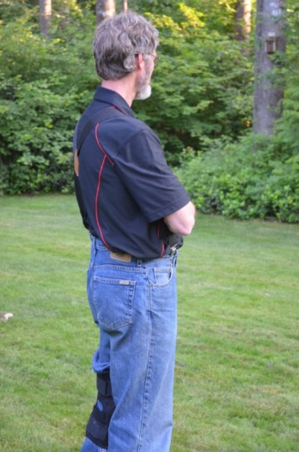
~Tuesday afternoon workshop~
“Dealing With Your Garden After Significant Weather Events”
Mark Bloom was born and raised in the Willamette Valley and began his career in the nursery business, in 1965, at a local retail nursery & landscape company called Brechtbill's Nursery. It was there that he began learning the science and art of growing healthy plants and the forces, both natural and manmade, that can keep that from happening. Though he didn't know it at the time, it would lead him on a life-long journey into nearly every aspect of the green industry.

He began his own business in 1978 as a wholesale nursery which worked best with his full-time teaching career. Ironically, though he taught for 25 years at every level, it wasn’t until his last year that he taught a course dealing with the horticulture. Mark's been witness to many of the weather extremes that have affected plant health throughout the west coast. From the “Big Snow” in 1969, the “Big Freeze” (the first one) in 1972, the “Siberian Express” in 1989, the most recent “Big Freeze” in 2013, and numerous other climatic events which have had various effects on plant health.

~Tuesday afternoon workshop~
“Natural Floral Design with Textures & Elements from the Garden”
Scott Sunderlund was born and raised in Oregon. Scott says his mom took pride in creating a beautiful garden and yard where he enjoyed helping her and learning about the annuals, perennials and shrubs that came second nature to her. That experience and the time he spent in natural forests near home instilled a great appreciation of nature and the flowers and plants that were available to create a pleasing colorful yard. While going to college he began working at a flower shop during Valentine’s Day and eventually became a floral designer. After graduating the job prospects were few so he continued his work as a floral designer at The Shamrock Flowers and Gifts. Two years later he became a partner in the business and for 25 years has been the sole owner of The Shamrock. During the past 30 some years he has seen many trends in the floral industry. Scott spends most of time dealing with the challenges of running a small business and overseeing an excellent floral team that creates beautiful, unique designs. He continues to appreciate nature and enjoys gardening and creating seasonal plantings in his yard and, of course, bringing flowers, twigs, and foliage into to his home, creating simple natural bouquets.
[Type a quote from the document or the summary of an interesting point. You can position the text box anywhere in the document. Use the Drawing Tools tab to change the formatting of the pull quote text box.]

